**Unit 6 Programming Project 2**

Solve the following programming problems by developing algorithm and then implementing it in Java. Please follow the instructions in your Blackboard course site to understand how to submit the project.

# Problem 1

The variable fuelAmount and fuelCapacity hold the actual amount of fuel, and the size of the fuel tank of a vehicle. If less than 10 percent is remaining in the tank, a status light should show a red color; otherwise it shows a green color. Simulate this process with the values of the fuelAmount and fuelCapacity read from the user, and the program printing “red” or “green” for the particular values.

**Answer:**

**Flowchart:**

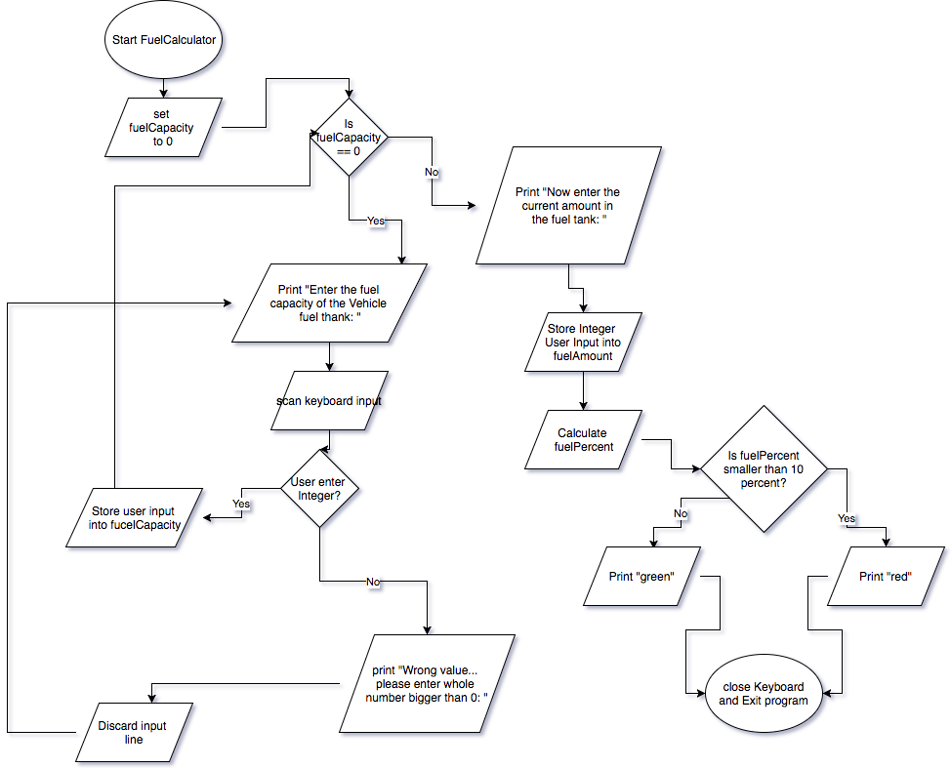

**Code:**

[**https://github.com/mauricext4fs/CSC110/blob/master/Programming Project 2/Problem1/Problem1.java**](https://github.com/mauricext4fs/CSC110/blob/master/Programming%20Project%202/Problem1/Problem1.java)

**Browxy screen shot:**

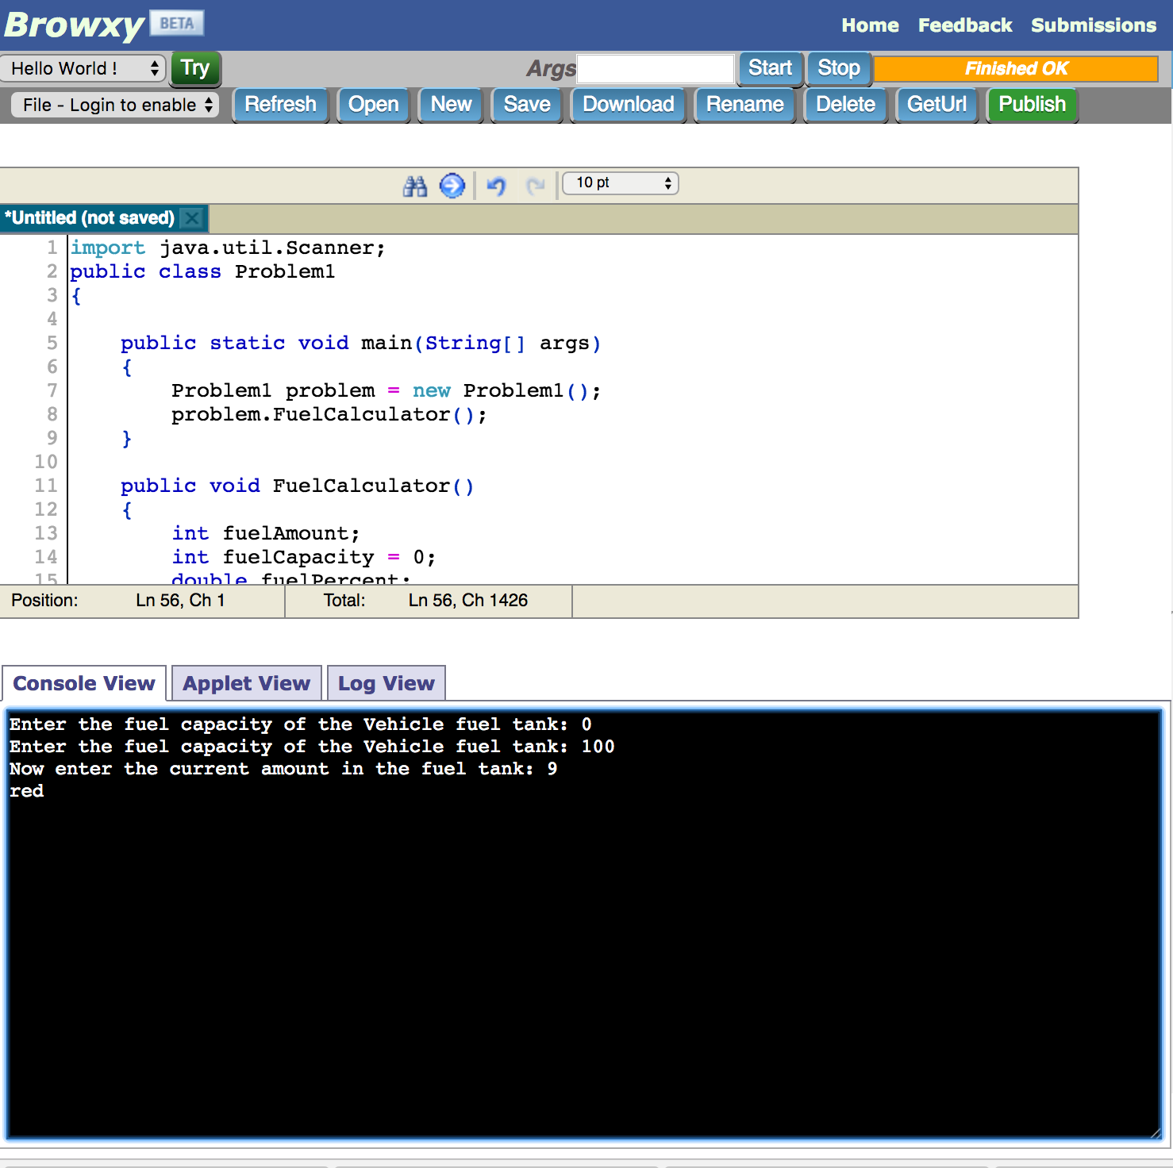

# Problem 2

The college bookstore has Kilobyte Day sale every October 24, giving an 8 percent discount of all computer accessory purchase if the price is less than $128, and a 16 percent discount if the price is at least $128. Write a program that asks the cashier for the original price, and then prints the discounted price.

**Answer:**

**Flowchart:**

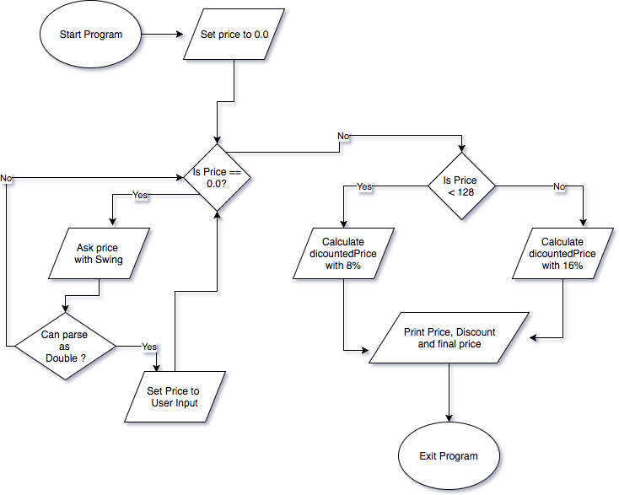

**Code:**

# https://github.com/mauricext4fs/CSC110/blob/master/Programming%20Project%202/Problem2/Problem2.java

**screen shot:**

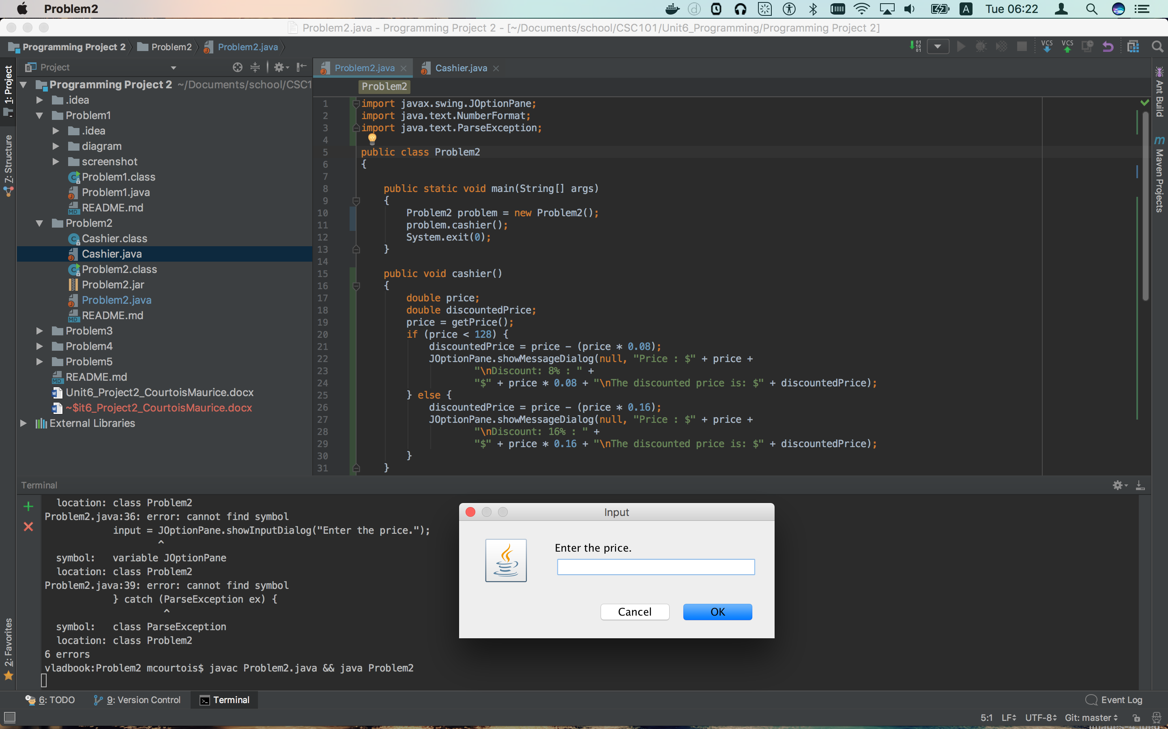

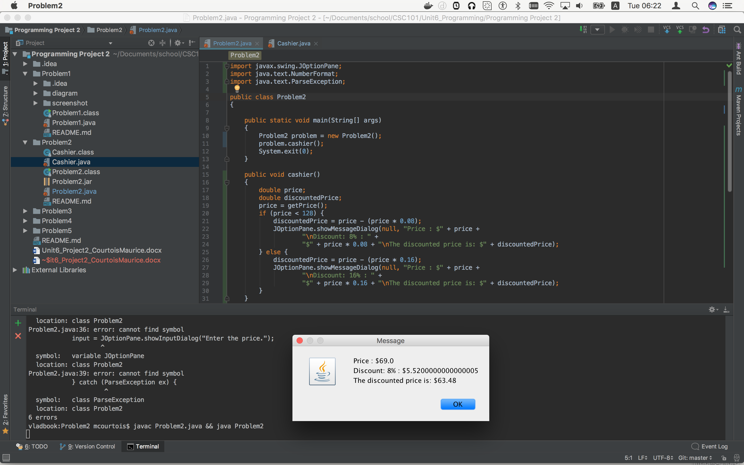

# Problem 3

Write a program that would help me calculate your letter grades according to the college policies: if the score is less than 60, grade is D, C is awarded for score between 70 and 79, B for 80 to 89, and A for 90 to 100.

# Problem 4

You have $10,000 in your bank account which earns 5 percent interest per year. How many years does it take for the account balance to be doubled?

# Problem 5

Using a for loop, calculate and display the multiplication table of numbers from 1 to 10.